CUSTOM BOOTCAMP
Azure Synapse Analytics

Creating Azure Synapse Analytics Workspace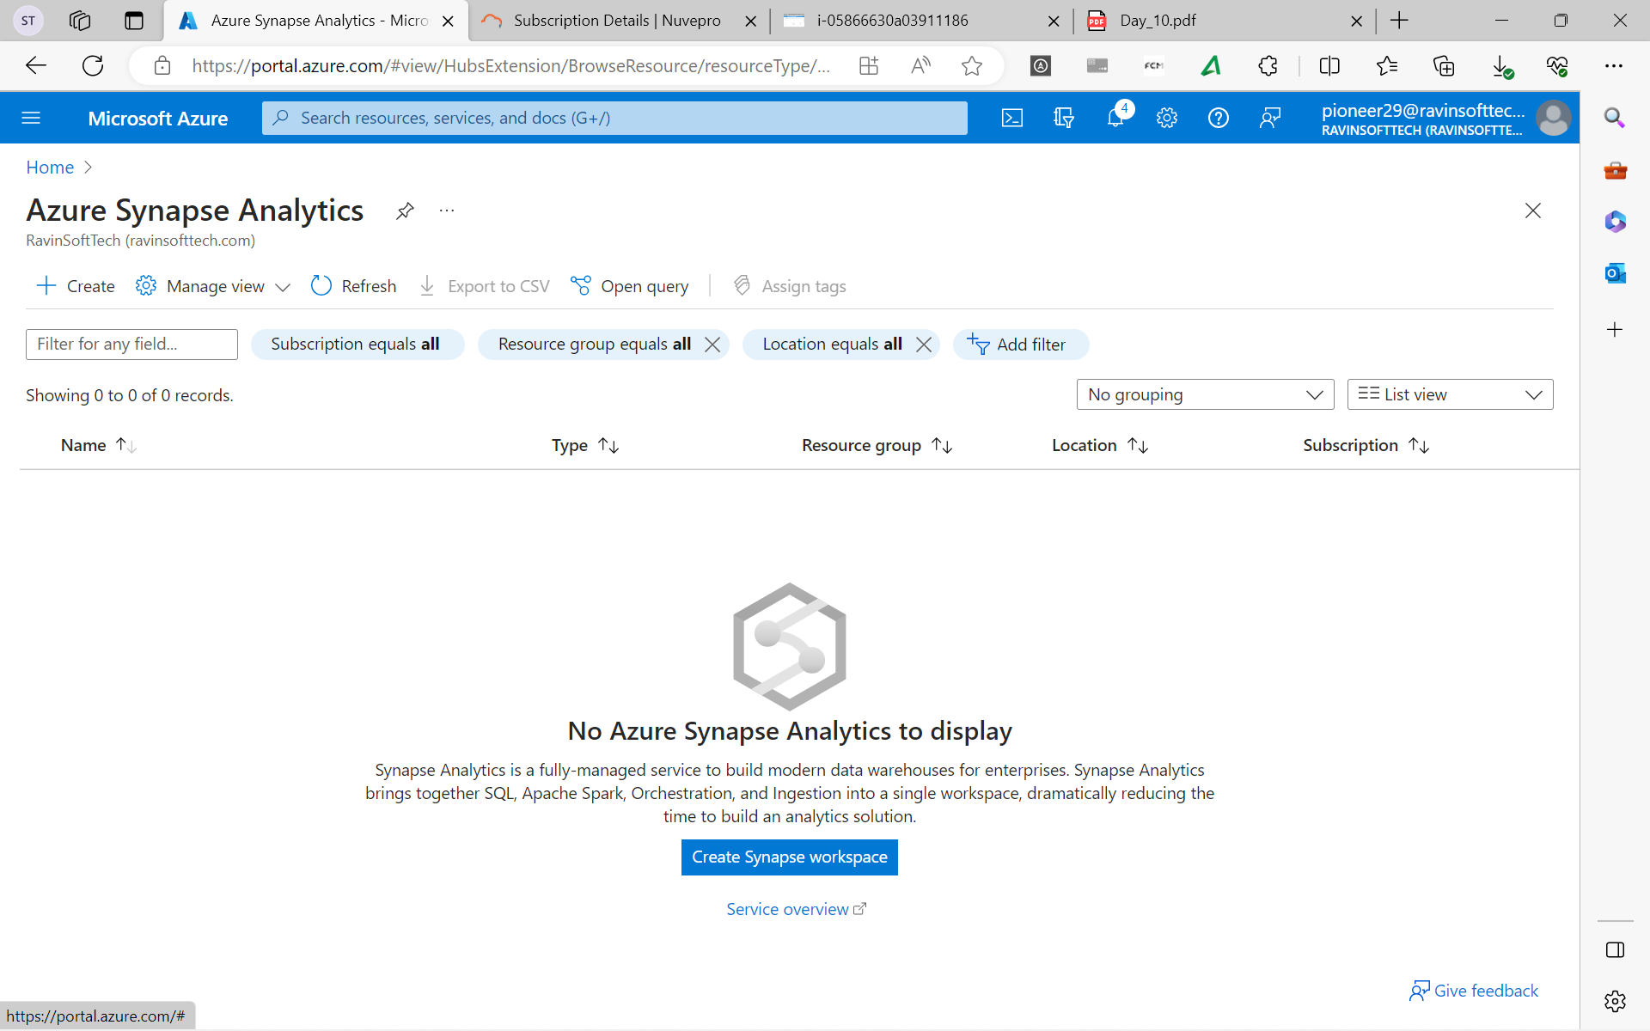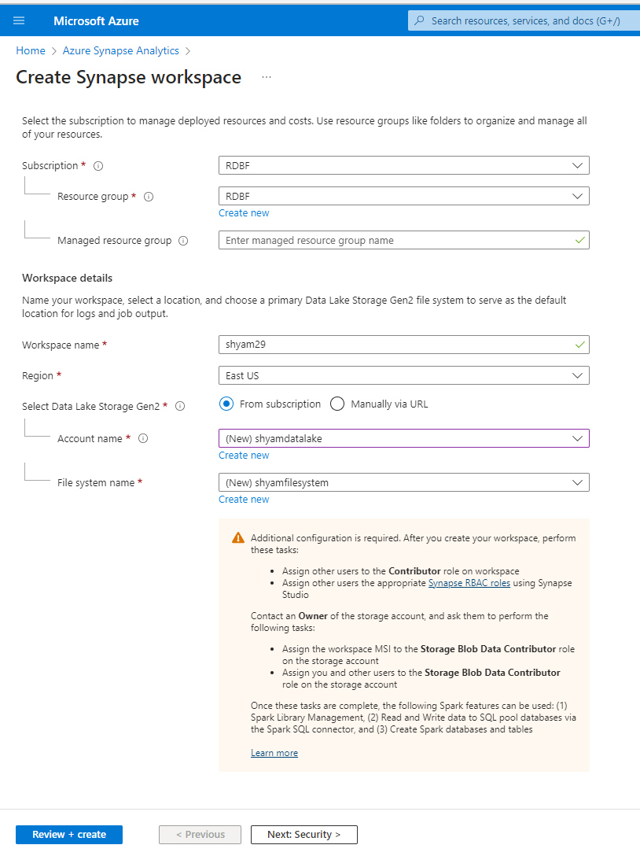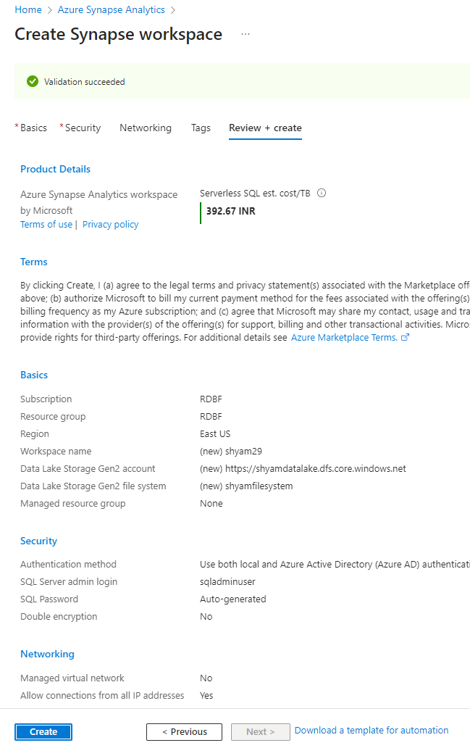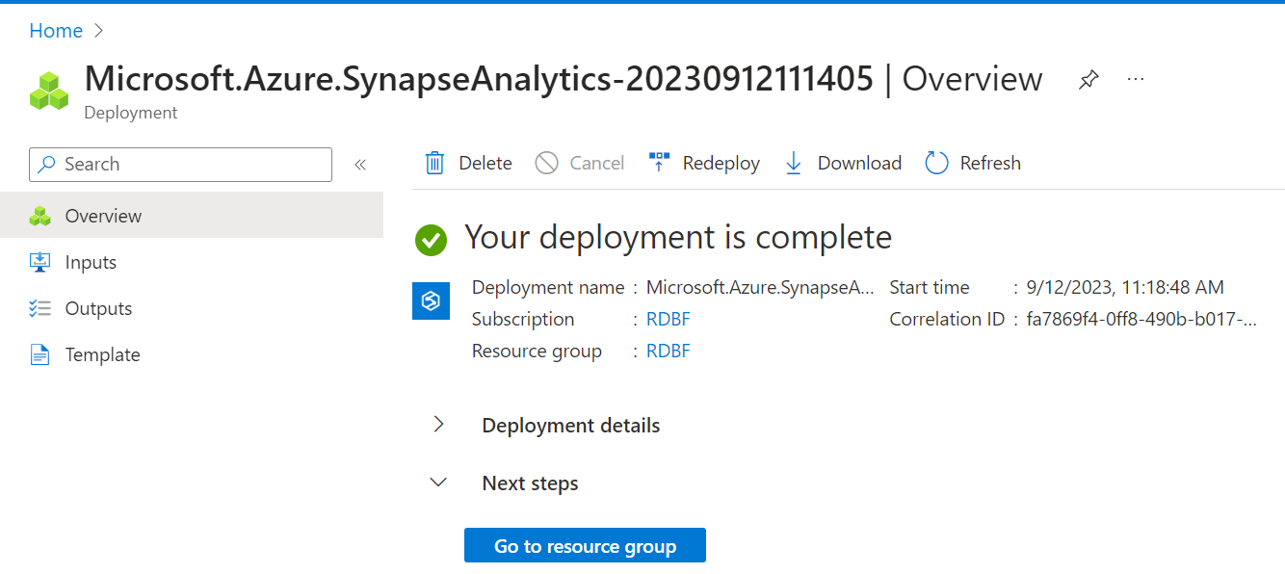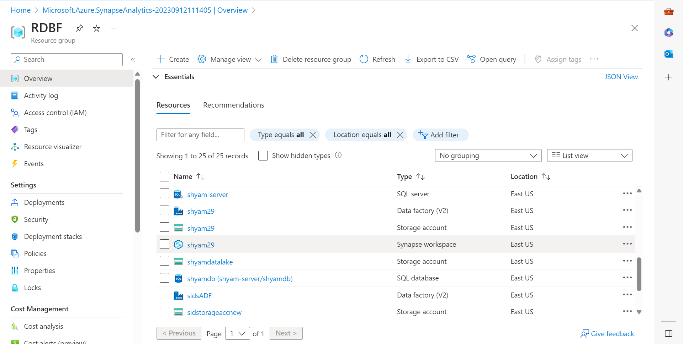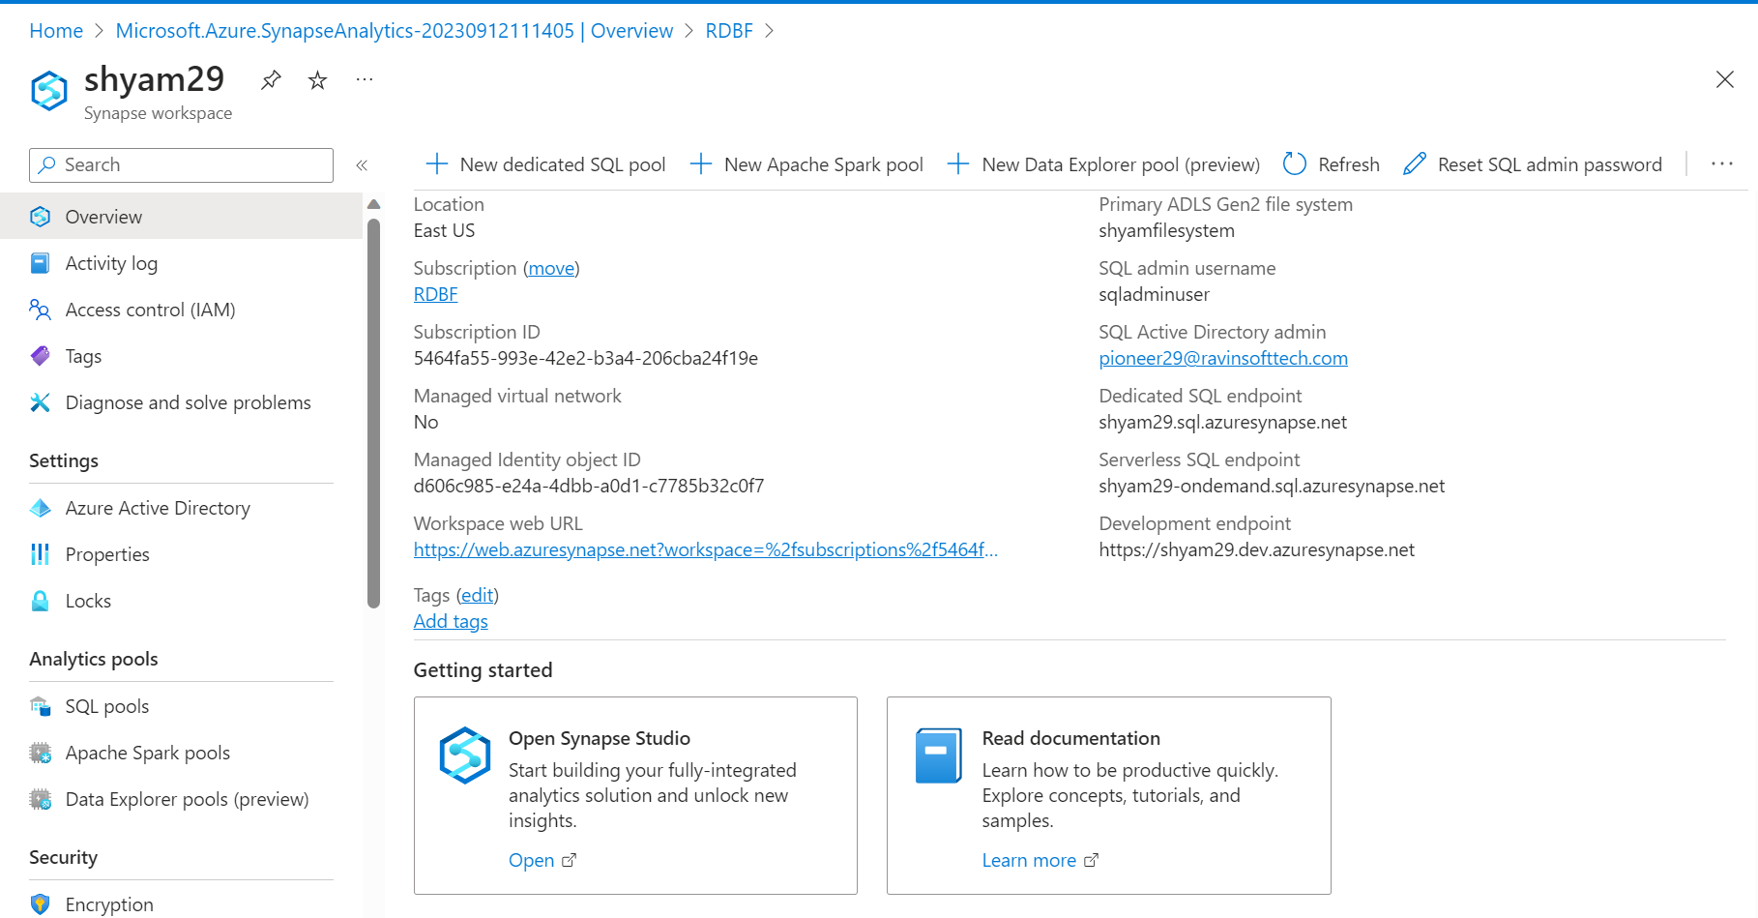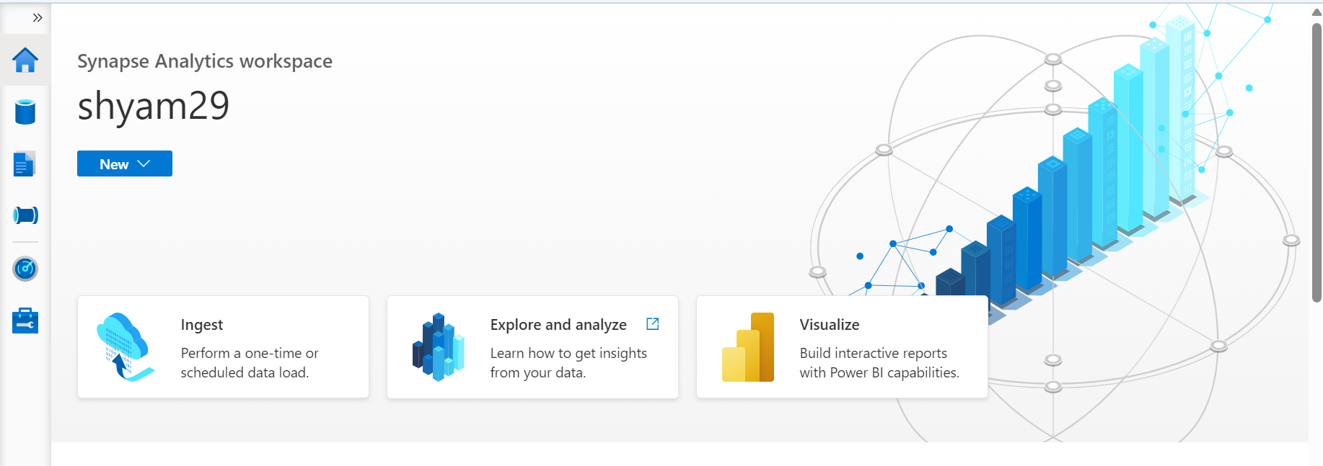

SQL Pools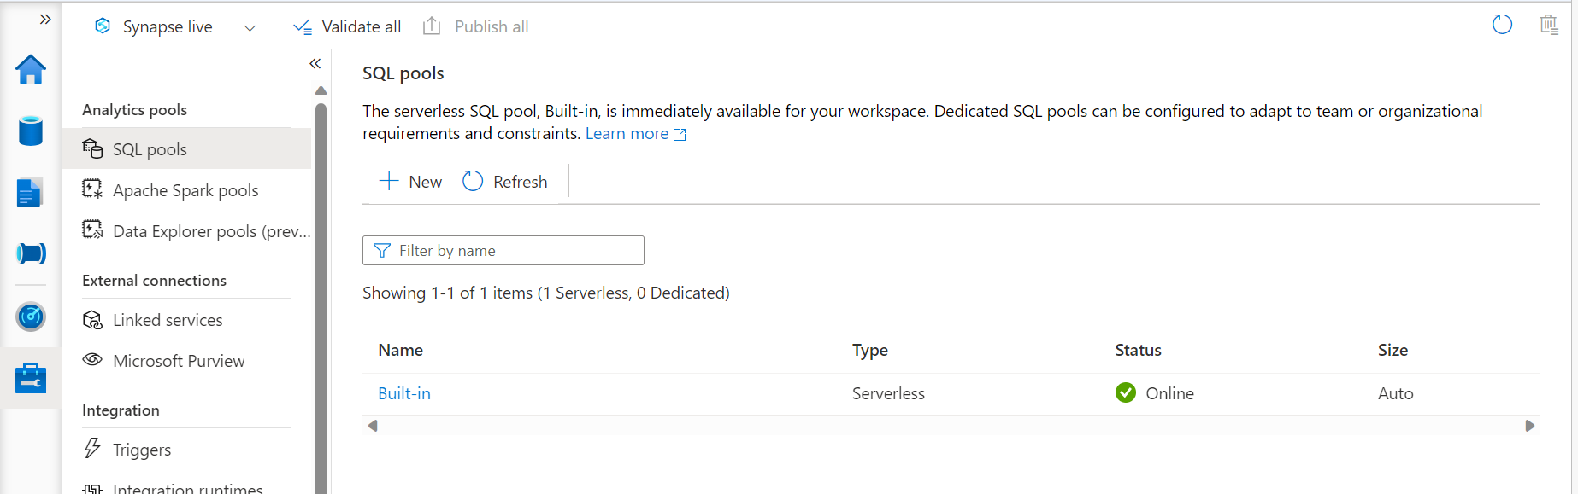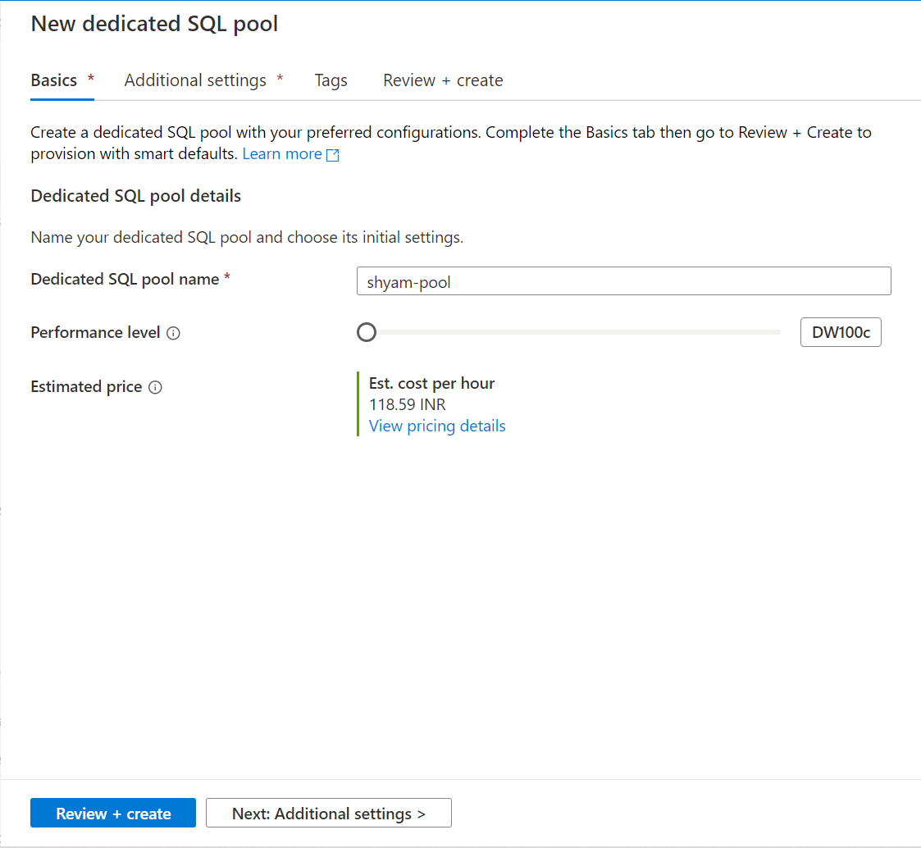
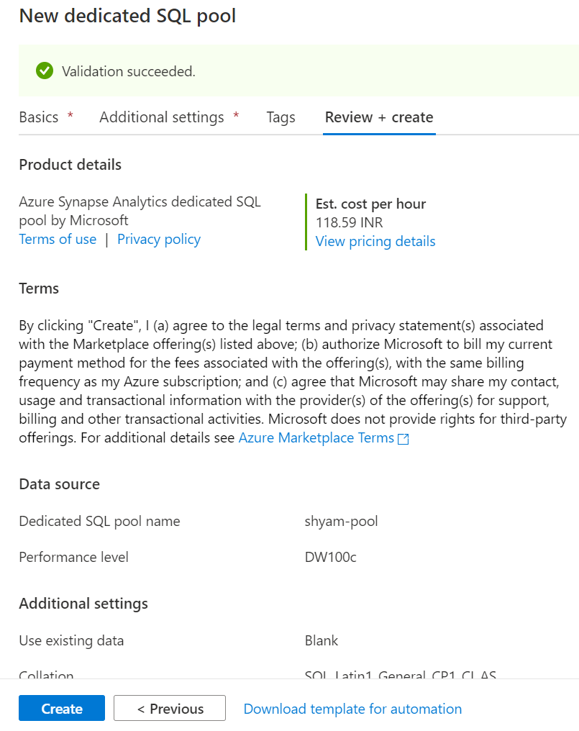

Serverless SQL Pool in Synapse Analytics
Every Azure Synapse Analytics workspace comes with serverless SQL pool endpoints that you can use to query data in the Azure Data Lake (Parquet, Delta Lake, delimited text formats), Azure Cosmos DB, or DataVerse.

Serverless SQL pool is a query service over the data in your data lake. It enables you to access your data through the following functionalities:
- A familiar T-SQL syntax to query data in place without the need to copy or load data into a specialized store. To learn more, see the T-SQL support section.
- Integrated connectivity via the T-SQL interface that offers a wide range of business intelligence and ad-hoc querying tools, including the most popular drivers. To learn more, see the Clients tool section.

Dedicated SQL Pool in Synapse Analytics
- Dedicated SQL pool (formerly SQL DW) refers to the enterprise data warehousing features that are available in Azure Synapse Analytics.
- Dedicated SQL pool (formerly SQL DW) represents a collection of analytic resources that are provisioned when using Synapse SQL. The size of a dedicated SQL pool (formerly SQL DW) is determined by Data Warehousing Units (DWU).

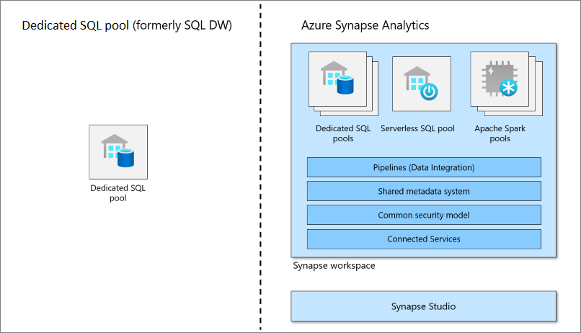

Differences Between Serverless and Dedicated SQL Pool
The basic differences between Synapse Serverless and the Dedicated pool are while the serverless doesn’t store data, only access data from storage accounts and scale the MPP environment automatically, the dedicate SQL Pool keeps a static number of servers according to the service level we choose and a constant number of distributions – always 60.

Serverless SQL Pools
- Idle for either structure or unstructured data. Data can be stored in different file formats (raw or parquet)
- The compute associated with the serverless SQL pool is managed and allocated by Microsoft.
- Seamless data transformation without any infrastructure in place

Dedicated SQL pools:
- Data is stored in relational tables.
- If you need an optimized compute strategy for performance requirements, go with dedicated (option to increase the Data warehouse units)
- Require dedicated servers before performing any operation.
- The performance is based on DWU (Data Warehouse Units)

Creating a Dataflow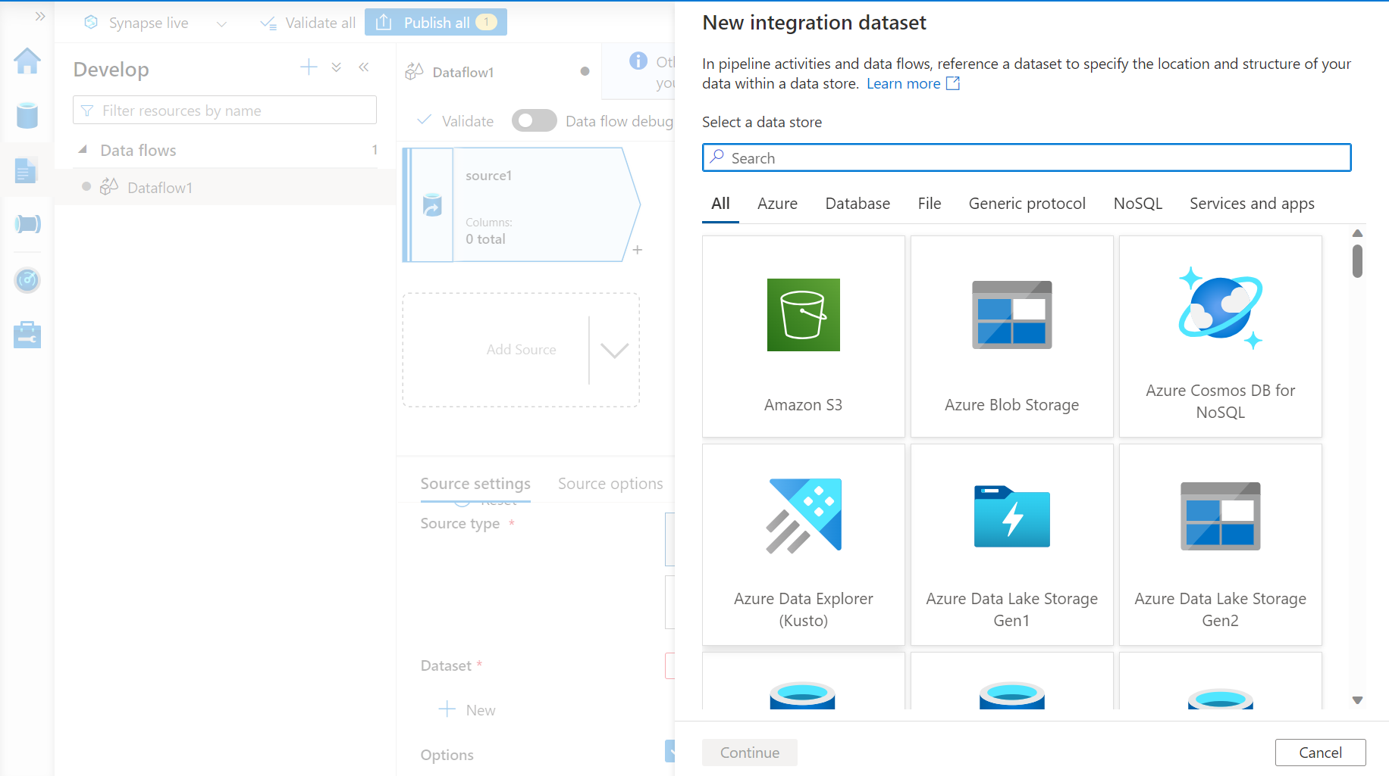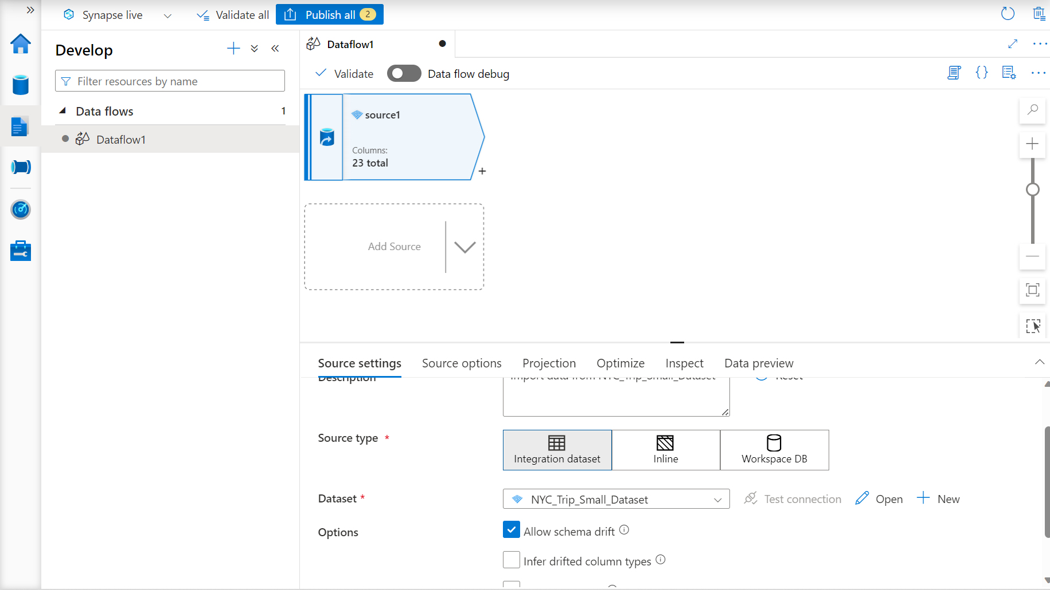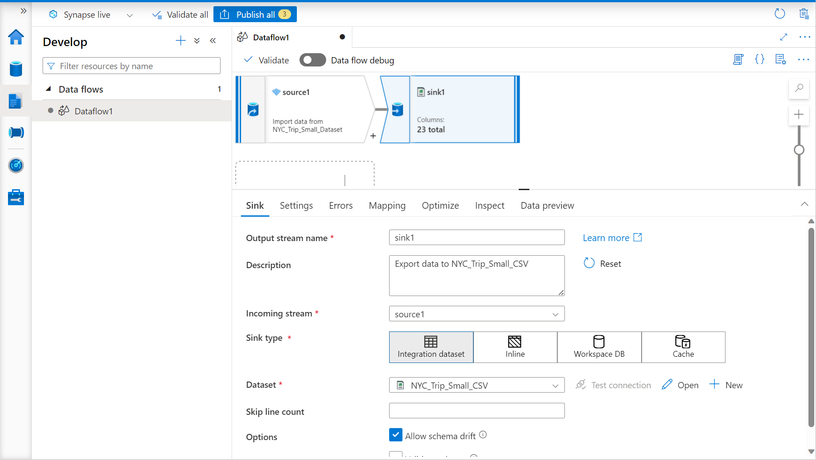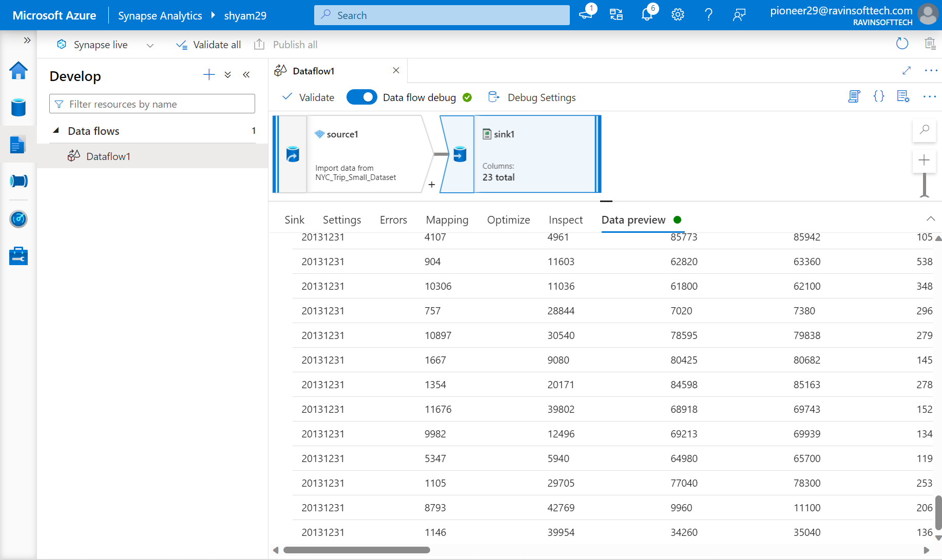
Creating Pipeline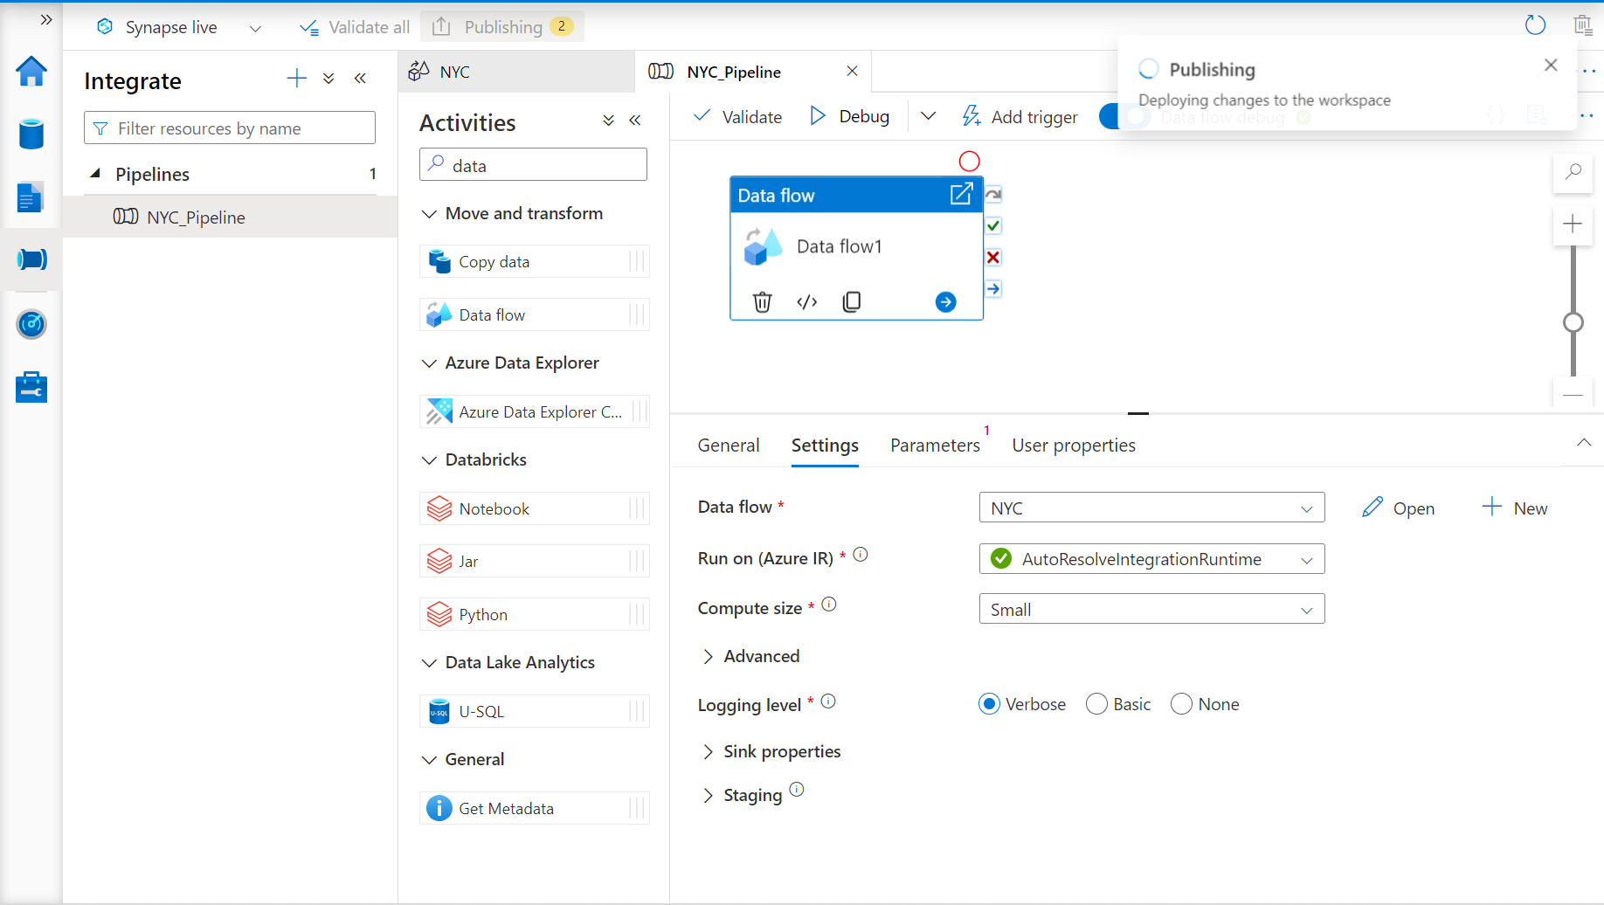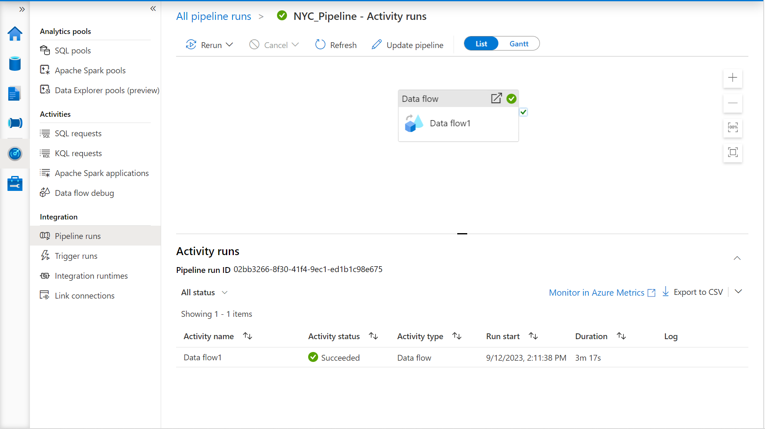

SQL POOLS
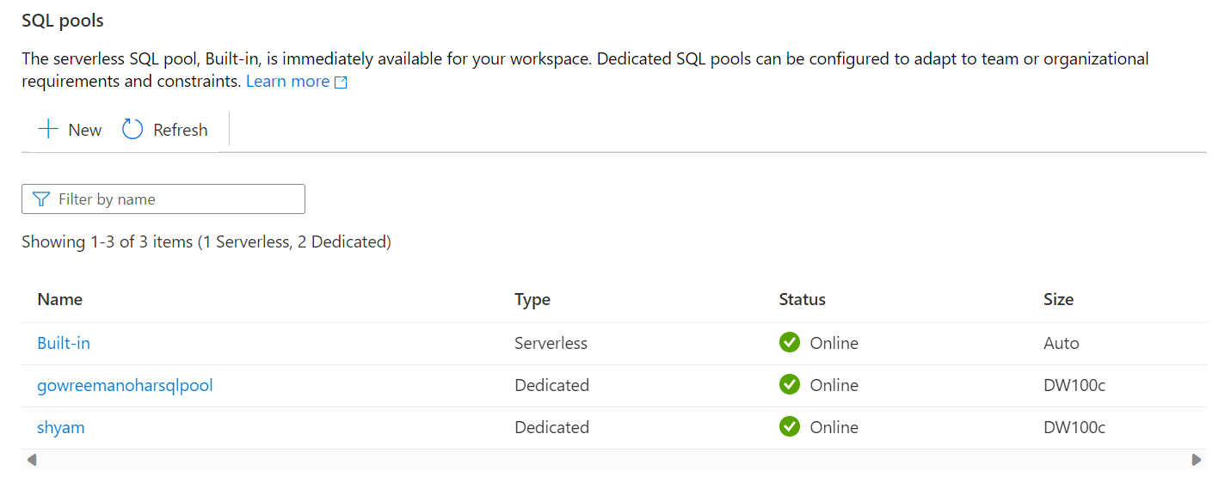

SQL DATABASE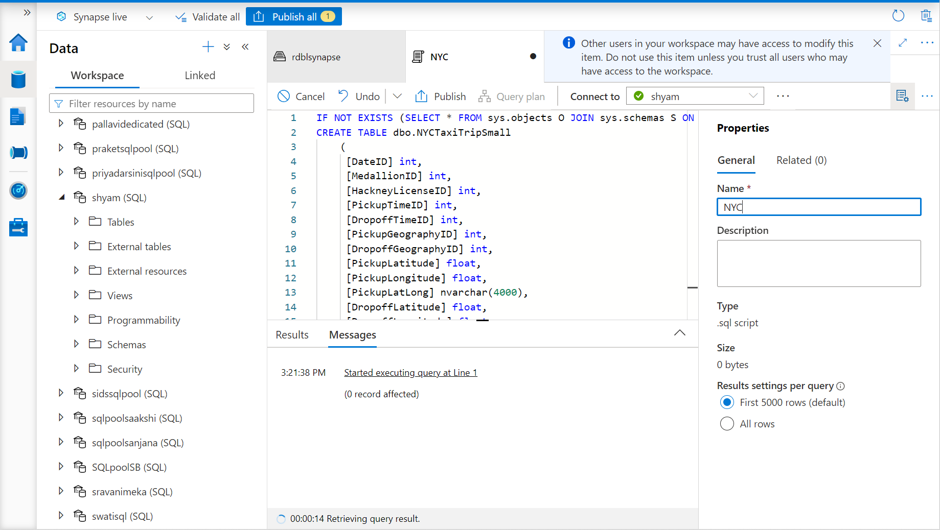
Running Queries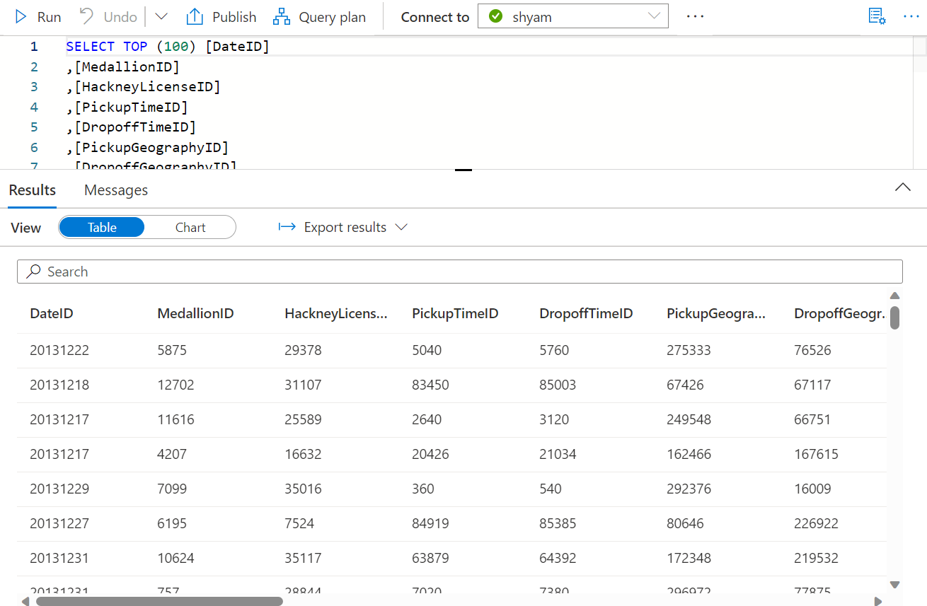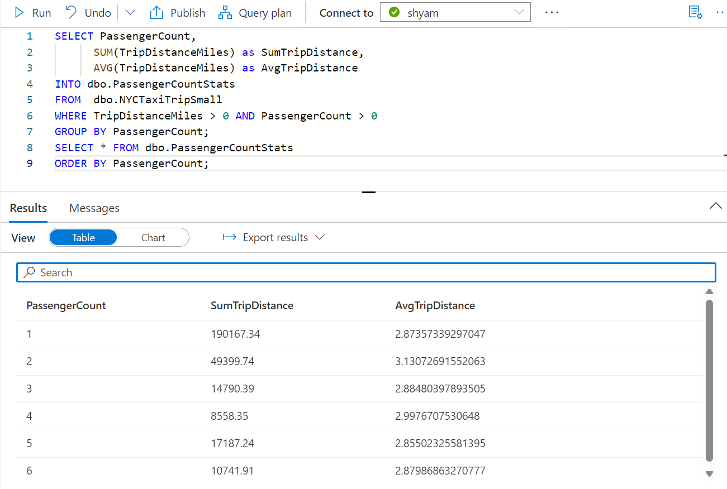
Creating Dataflow from SQL DB